**/Views/Students/Index.cshtml**

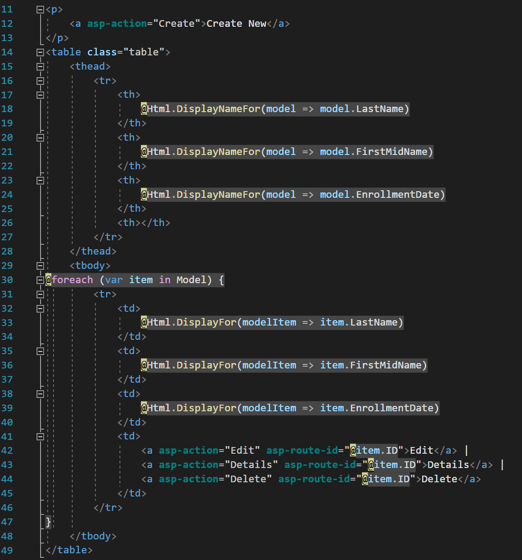

**/Views/Students/Edit.cshtml**

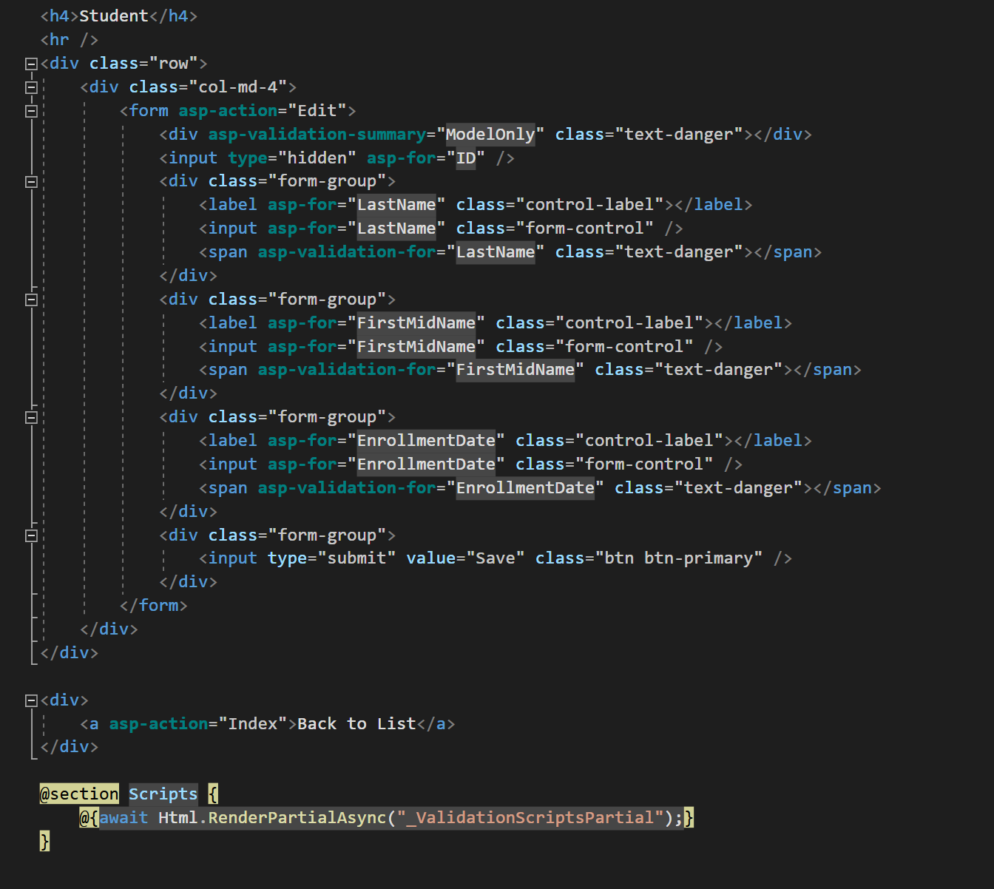

**SQL Server Object Explorer Window**

